Dear Jimmy Blackburn and Alesha Eisen,

Is my pleasure to share with you the summary the final report for Big Mountain Ski Resort Pricing Model, comparing current pricing strategy and conditions with data from USA market, including 330 resorts. The project objective was to develop a cost contingency or pricing strategy for Big Mountain to offset an additional $1,540,000 in operational costs. As well as giving advice to the resort about how to optimize ticket pricing as well as how to reduce costs without affecting prices or justify higher rates.

The overall process followed in this project consisted of 6 steps:

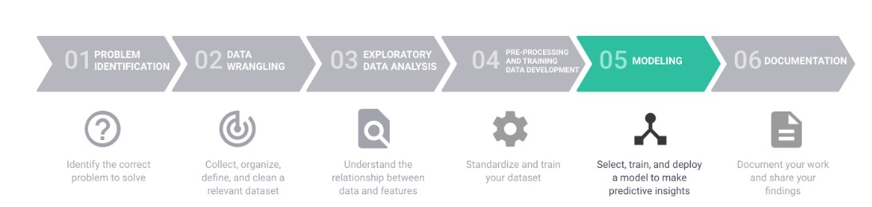

As part of the step #6 in this report I will summarize the key insights and recommendations.

1. **Pricing Opportunities:** Machine Learning Model Price Prediction with current Conditions of Resort compared to overall USA market.

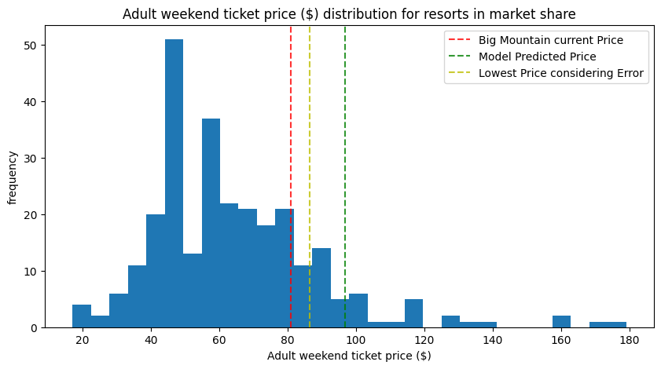

Big Mountain Resort model recomended price is $96.84, actual price is $81.00. Even with the expected mean absolute error of the model ($10.35), there is room for an increase by $5.49 USD per ticket at least. I recommend to price up as a short term action.

1. **Premium Resort:** Big Mountain is the most expensive resort in Montana, so the pricing strategy should be balanced with “Value Proposition Selling”, to leverage the unique offer that Big Mountain Resort brings to its visitors.

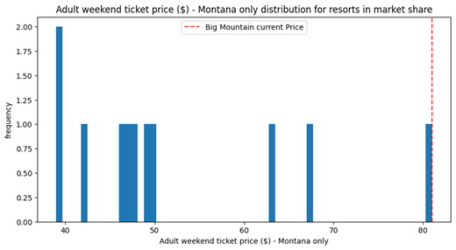

1. **Differentiators:** Our model determined that the dominant top five features that are correlated positively with price: Fast Quads, Runs, Snow Making_ac, Total Chairs and vertical_drop. Coincidently, Big Mountain has an amazing premium differentiation on those 5 features. As you can see graphically in the next 5 plots:

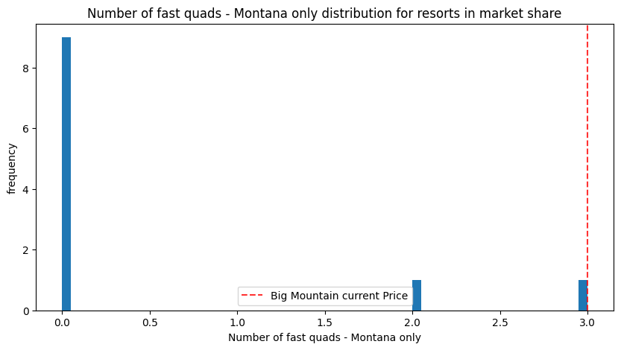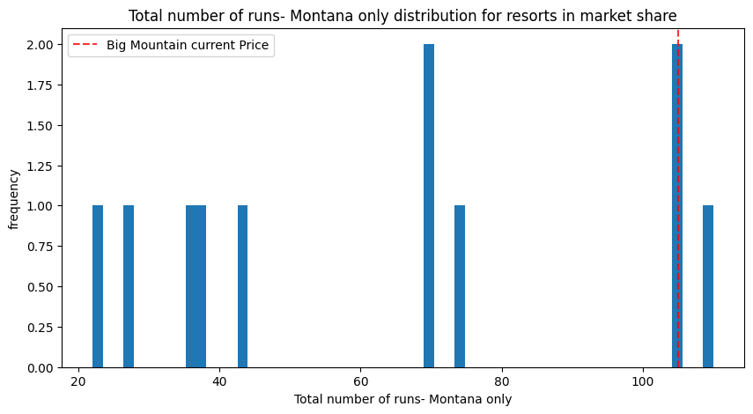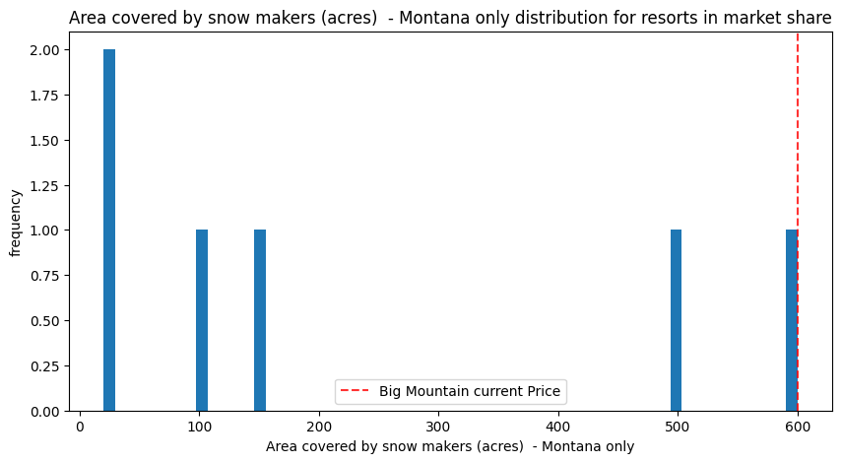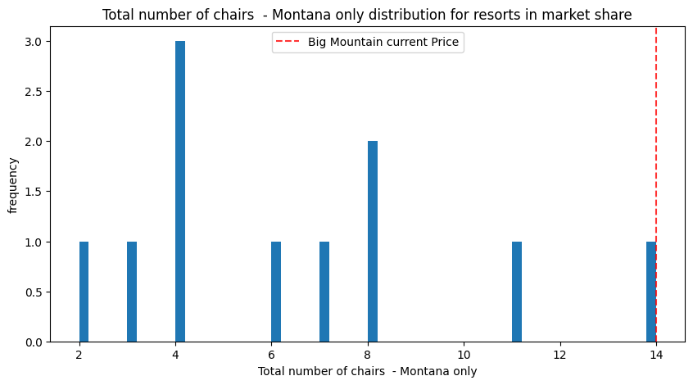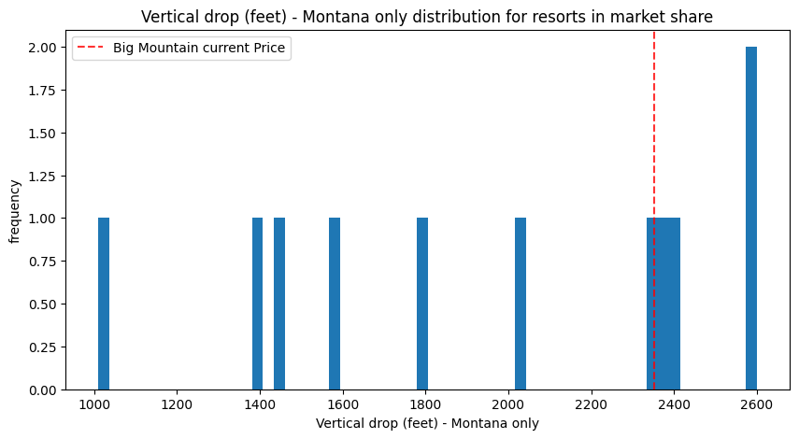

The following Matrix shows how the price is strongly affected by those 5 variables.

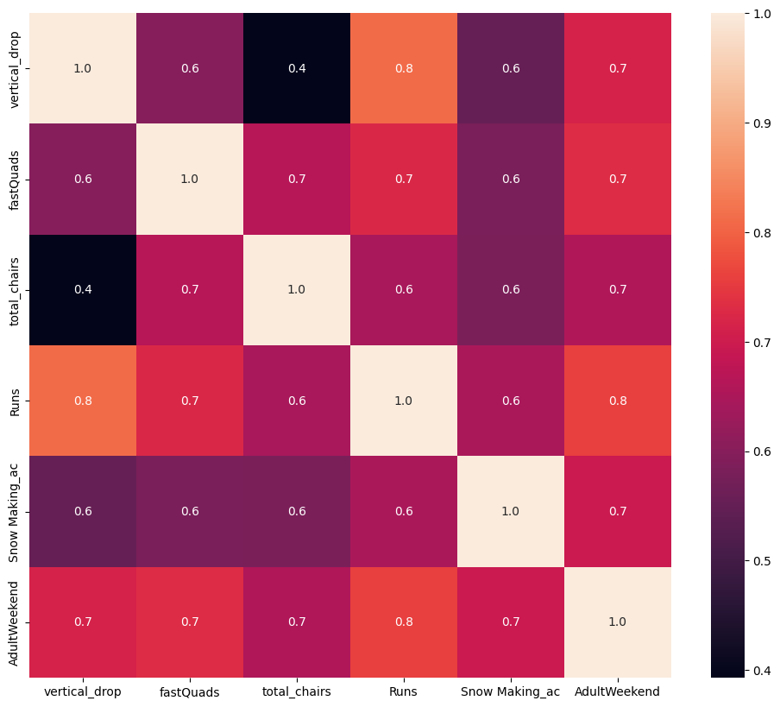

1. **Cost Modeling Scenarios:** 4 Scenarios where modeled:

* Scenario 1: Permanently closing down up to 10 of the least used runs. This doesn't impact any other resort statistics.
* Scenario 2: Increase the vertical drop by adding a run to a point 150 feet lower down but requiring the installation of an additional chair lift to bring skiers back up, without additional snow making coverage
* Scenario 3: Same as number 2, but adding 2 acres of snow making cover
* Scenario 4: Increase the longest run by 0.2 mile to boast 3.5 miles length, requiring an additional snow making coverage of 4 acres

Scenario 1 was disregarded because price would decrease after the first run closed:

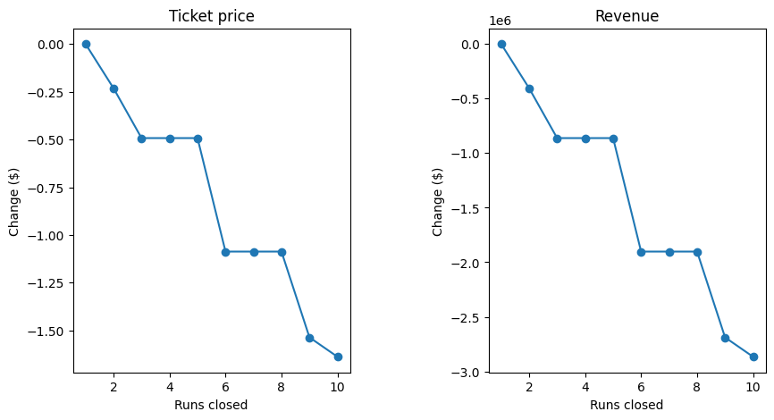

Scenario 4 is disregarded because the impact would be $0, as well as Scenario 3, because its outcome would be marginal.

Scenario 2 seems to be the most promising as it could support ticket price by $2.97, which considering 350,000 visitors, with 5 days average would increase sales by $5.2M in a year. However more detailed investigation should be done in regard to Involved costs of this decision, as current data didn’t include any cost features.

**Conclusion:**

Before moving on with Scenario 2, I highly recommend exploring in midterm, the strategy of “Premium Value Proposition Offer” described in this document. This Strategy doesn’t focus on cost or any Capital Expense, but in income. This would only require some Marketing Budget and intensive Actions. If the brand could make use of its current 5 differentiators to justify a Price Increase as Premium Service, the potential earnings per year could rise to: 9.78 Mi USD in best case.

If you have any questions or thoughts, please feel free to reach out to me.

Best Regards,

Javier Jorge Pérez Ontiveros

Founder and CEO, Gemhack

*“Blend of Data, Technology and Strategy”*

